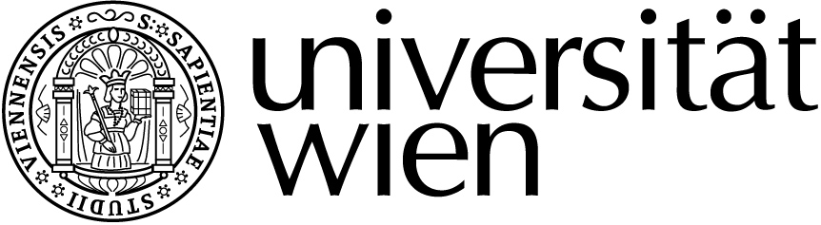
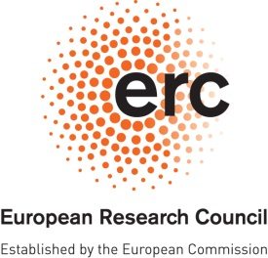
"The Emergence of Relativism" Department of Philosophy

Prof. Nuño Venturinha
(Lisbon)

will give a public lecture entitled

"Moral Relativism"

Friday, 29 January 2016,
3.30 – 5.30 pm
Room 3D (NIG, Universitätsstraße 7, 3rd floor)

The talk is open to all.

For further information, please contact:
Prof. Martin Kusch
Email: martin.kusch@univie.ac.at
Phone: 01 4277 46422

